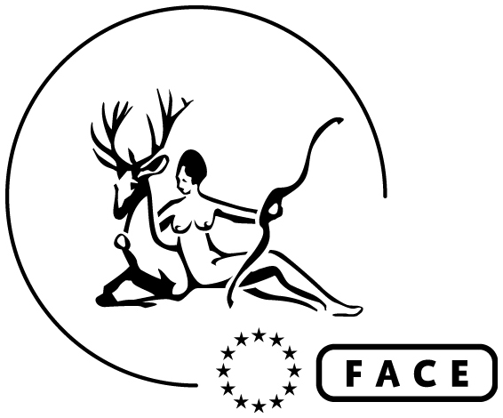

Application Form – Wildlife Policy Officer

First Name:
Last Name:
Postal address: |  | Date:
Email address: | Phone number:

Please, answer those questions to complete your application:
- Please describe how your skills, knowledge and experience meet the criteria in this job proposal.
Max. 500 words
- Please provide an example of how you have planned and prioritised work tasks in your current or most recent position. Max. 300 words
- Describe a situation in which you had to meet a critical deadline? What did you do, and what was the result? Max. 300 words
- In your opinion what are the greatest challenges to nature conservation in the EU?
Max. 300 words

